AI FAQ ASSISTANT
An Intelligent Question Answering System
PROJECT DOCUMENTATION

Team: Team – 3
Team Lead: Manju R
Team id: SWTID-2026-9290
Team Members: Gopika K, Mahalakshmi M, Keerthika R, Vaigaiselvi E
College: Bhaktavatsalam Memorial College for Women
PROJECT DESCRIPTION

Project Title
Askly-AI FAQ Assistant – An Intelligent Question Answering System

Project Description

The AI FAQ Assistant is an AI-Augmented backend Web Application built with MongoDB, Express.js, and Node.js. It integrates AI capabilities such as Large Language Models (LLMs), with Semantic Search, Vector Search, and Intelligent Recommendations identified as future extensions to the current FAQ search experience. Users can browse and manage a shared FAQ knowledge base, ask questions in natural language, receive AI-generated answers and FAQ drafts, and use these insights to improve knowledge access and productivity. The modular API and MongoDB-backed architecture provide a foundation for scaling the application as its knowledge base and user community grow.

Project Overview
The project provides a centralized platform for managing FAQs and generating answers efficiently. Users can create and manage FAQ information, search for relevant questions, and obtain AI-generated answers based on their input. The system consists of features such as Register, Login, Profile, FAQ management, FAQ search, and AI answer generation.

Team Details
- Team: Team – 3
- Team Leader: Manju
- Team id: SWTID-2026-9290
- Team Members: Gopika, Mahalakshmi, Keerthika, Vaigaiselvi
- College: Bhaktavatsalam Memorial College for Women

SCENARIO

Problem
Managing frequently asked questions manually can make it difficult for users to find the required information quickly. Users may also need a convenient way to create, update, delete, and search FAQs.

AI Solution
The AI FAQ Assistant combines FAQ management with AI-based answer generation. Users can manage FAQ information and search for relevant FAQs. When required, the system can generate an answer from a question or topic, making the system more interactive.

Impact
The system provides a centralized platform for FAQ management and answer generation. It helps users retrieve FAQ information and obtain generated answers based on questions or topics.
SYSTEM REQUIREMENTS
Functional Requirements:
- User Registration – Allows a new user to register
- User Login – Allows registered users to log in.
- Profile – Provides access to user profile information.
- Get All FAQ – Retrieves all available FAQs.
- Create FAQ – Allows creation of a new FAQ.
- Get FAQ by ID – Retrieves a specific FAQ using its ID.
- FAQ Update – Allows an existing FAQ to be updated.
- Delete FAQ – Allows an FAQ to be deleted.
- Search FAQ – Allows users to search for FAQs.
- AI Answer Generation with Question – Generates an answer based on a question.
- Generating Answer with Topic – Generates an answer based on a topic.
Software Requirements:
- Windows 10/11
- Node.js (v18+)
- npm (v9+)
- Express.js
- MongoDB Community Server / Atlas
- MongoDB Atlas Search
- MongoDB Atlas Vector Search
- Thunder Client
- Visual Studio Code
- Git/GitHub
Hardware Requirements:
- Intel Core i3 (8th Gen+)
- Minimum 8 GB RAM (16 GB Recommended)
- Minimum 5 GB Free Storage
- Internet Connection
- A 1366 × 768 display

AI Service and Orchestration
- AI Service Provider:Google Gemini (implemented)
- AI orchestration tool: Google gemini SDK
- Current model configuration: gemini-3.6-flash

Technology Stack – Backend Node.js is used as the backend technology for the AI FAQ Assistant project. It handles server-side operations and supports API functionalities including user registration, login, profile management, FAQ management, FAQ search, and AI-based answer generation.

PROJECT ARCHITECTURE

The AI FAQ Assistant backend is built on a layered architecture to separate routing, business logic, data persistence, and external AI integrations.

Backend Layer: The entry point is src/server.js, which connects to MongoDB and starts the HTTP server on a configured port. The src/app.js file acts as the Express gateway, configuring CORS, body parsers, static asset serving, and centralized error handling. Route modules map HTTP paths to specific controllers.

Database Layer: MongoDB serves as the persistent data store, managed through the Mongoose ODM. The system connects via a URI (supporting local or MongoDB Atlas instances) and defines strict schemas for User and FAQ entities.

AI Layer: The AI integration is isolated in src/services/geminiService.js, which connects to the Google Gemini API using the @google/genai SDK. This layer manages structured JSON responses for FAQ generation, direct text answers, and handles retry logic for transient API failures.

Storage Layer: All user and FAQ data is stored in MongoDB. The system does not utilize external object storage buckets, vector embeddings collections, or server-side cache layers. The client browser stores JWTs locally for session management.

Security Layer: Security is enforced through multiple mechanisms. Passwords are encrypted using bcrypt within a Mongoose pre-save hook. Protected API routes require a 30-day JSON Web Token (JWT) sent via a Bearer authorization header. Write operations on FAQs strictly validate that the requester's ID matches the FAQ's createdBy property.

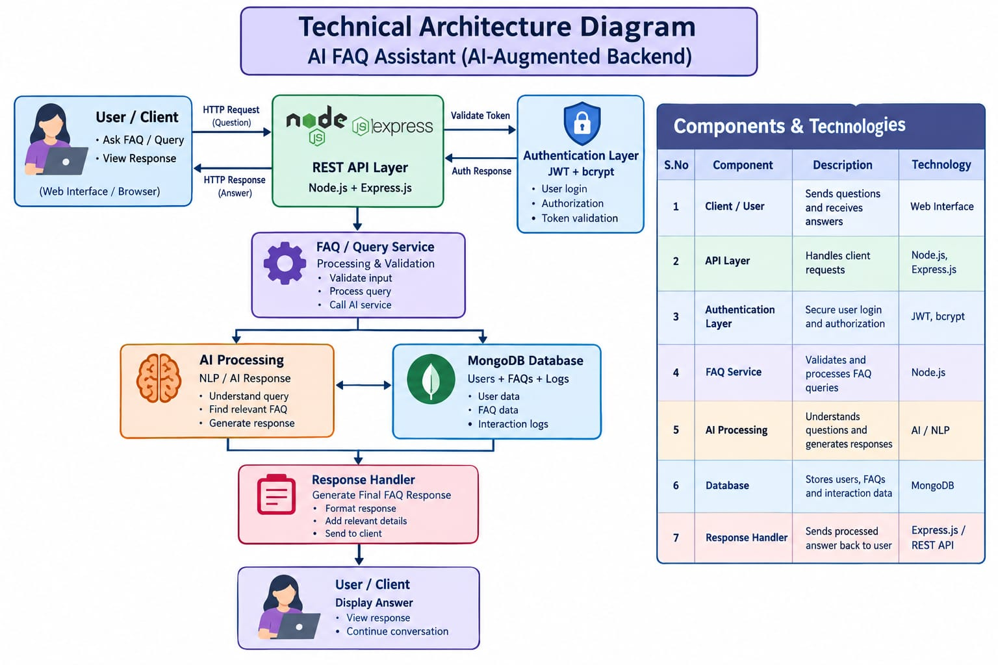

System & Detailed User Flow
- A visitor opens the web interface where the browser loads the public FAQ list via GET /api/faqs.
- The visitor searches for information using keyword matching (GET /api/faqs/search?q=...) or views a specific item.
- The visitor registers an account by submitting their name, email, and password to POST /api/auth/register.
- The backend validates the payload, hashes the password via bcrypt, stores the user, and issues a 30-day JWT.
- The browser stores this JWT in localStorage and automatically attaches it as a Bearer token for all protected API requests.
- The user accesses their dashboard, retrieving profile data via GET /api/auth/profile.
- The user leverages the AI integration by submitting a topic to POST /api/ai/generate-faq or a direct question to POST /api/ai/answer.
- The user reviews the Gemini-generated draft and saves it to the database via POST /api/faqs.
- The user manages their content by updating (PUT /api/faqs/:id) or deleting (DELETE /api/faqs/:id) FAQs; the system verifies the createdBy field matches their specific user ID.
- Upon logging out or receiving a 401 Unauthorized response, the browser clears the token and reverts the user to the public experience.

ER Diagram
The system utilizes MongoDB for persistent storage with a one-to-many (1:N) logical relationship where one User can create many FAQs.
- Users Collection (User): _id (ObjectId PK), name (String), email (String, unique), password (String, hashed), createdAt/updatedAt (Dates).
- FAQs Collection (FAQ): _id (ObjectId PK), question (String), answer (String), category (String enum), createdBy (ObjectId FK referencing User), createdAt/updatedAt (Dates).

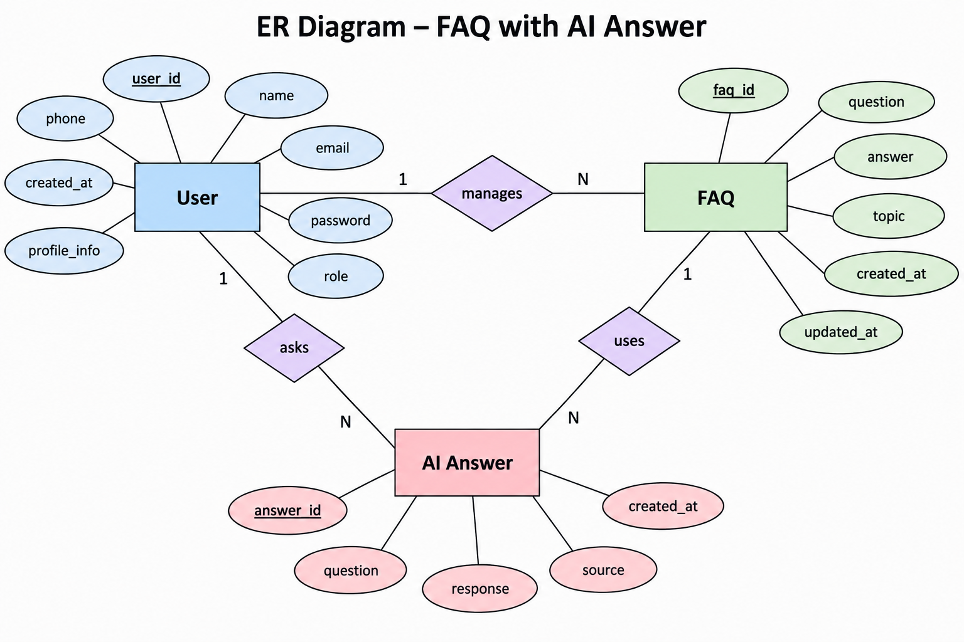
Entity | Documented Purpose | Relationship / Use
User | Registration, login, profile access | User manages or accesses FAQ functionality
FAQ | Create, retrieve, update, delete, search | FAQ information is managed by the system
AI Answer | Generate answer from question or topic | Uses user-submitted question/topic to produce a response

Core Logical Relationship: The system operates on a one-to-many (1:N) relationship where one User can create many FAQs.

User to FAQ Management: A User manages and accesses the FAQ functionality. Each FAQ requires exactly one creator reference linked to the User who authored it. When FAQs are read publicly, the system only populates the creator's name and email.

User to AI Generation: A User submits a question or topic to the system, which then uses the AI Answer Generation module to produce a response.

System Scope: The current logical architecture focuses purely on Users and FAQs; there are no separate database collections for Documents, Embeddings, Activity Logs, or Sessions.

Core Logical Relationship: The system operates on a one-to-many (1:N) relationship where one User can create many FAQs.

User to FAQ Management: A User manages and accesses the FAQ functionality. Each FAQ requires exactly one creator reference linked to the User who authored it. When FAQs are read publicly, the system only populates the creator's name and email.

User to AI Generation: A User submits a question or topic to the system, which then uses the AI Answer Generation module to produce a response.

System Scope: The current logical architecture focuses purely on Users and FAQs; there are no separate database collections for Documents, Embeddings, Activity Logs, or Sessions.

FEATURES & ROLES
Roles and Responsibilities The system relies on authentication-level access control rather than database-backed admin roles.
- Public Visitor: Can browse the FAQ list, retrieve specific FAQs by ID, execute keyword searches across FAQs, register a new account, and log in.
- Authenticated User: Can retrieve their private profile, create new FAQs, update or delete the specific FAQs they authored (enforced via ownership authorization), generate direct AI answers, and generate structured AI FAQ drafts.

Core Backend Features

    - User Registration/Login
    - JWT Authentication
    - Protected Routes
    - Middleware
    - CRUD API
    - File Upload (planned; not currently implemented)
    - Role-Based Access Control (planned; not currently implemented)

AI Features

- AI Chat Assistant (implemented as a protected single-question answer endpoint)
- Semantic Search (planned; current search is keyword/regex based)
- Vector Search (planned)
- Document Question Answering (planned)
- Text Summarization (planned)
- Content Generator (implemented for FAQ question-and-answer drafts)
- RAG (planned)
- Intelligent Insights (planned)
- Natural Language Queries (AI answers are supported; natural-language retrieval against the FAQ library is not currently implemented)

Roles

Admin: Manage Users/Documents, Monitor AI, View Analytics, Configure System. These are target role capabilities; an Admin role and administrator authorization rules are not currently implemented.
User :Register/Login, Upload Documents, Ask Questions, Search, View Recommendations, Manage Personal Data. Registration/login, asking questions, FAQ search, and creator-owned FAQ management are available; document upload and recommendations are future capabilities.

User Flow

The target end-to-end flow is:

User Registration -> User Login -> JWT Authentication -> Dashboard Access -> Upload Documents -> Generate Embeddings -> Store Vectors in MongoDB -> User Query Submission -> Semantic Search Execution -> AI Response Generation -> Display Results -> Store Chat History.

In the current application, the available flow is: register or log in -> receive and use a JWT -> browse or search FAQs, manage FAQs created by the signed-in user, ask the AI a question, or generate an FAQ draft -> review results in the web interface. Document upload, embedding generation, vector storage, semantic retrieval, and persistent chat-history storage are not yet part of the implementation.

MVC PATTERN

The project follows a lightweight, REST-oriented Model-View-Controller (MVC) structure to ensure a clear separation of concerns.

Model Layer: Located in src/models/, the User.js and FAQ.js files define the Mongoose schemas. This layer is responsible for strict data validation rules, database constraints (like unique emails and category enums), relationship mapping, and lifecycle hooks like password hashing.

Controller Layer: Located in src/controllers/, this layer contains the core business logic.

authController.js handles user registration, login, and profile retrieval.

faqController.js processes FAQ CRUD operations, ID validation, ownership checks, and keyword search queries.

aiController.js coordinates incoming requests with the Gemini service for automated answer and FAQ generation.

View / API Layer: The Express route modules inside src/routes/ (authRoutes.js, faqRoutes.js, aiRoutes.js) act as the API View layer by exposing the controller functions as accessible HTTP endpoints. The actual user interface View is handled completely separately by static HTML, CSS, and JavaScript files served from the public/ directory.

Supporting Middleware: The MVC structure is supported by custom middleware located in src/middleware/, which intercepts requests to verify JWT tokens (authMiddleware.js), validate payload formats (validationMiddleware.js), and format unified error responses (errorMiddleware.js) before they reach the controllers
Advantages
- Separation of concerns
- Maintainability
- Scalability
- Reusable components
- Team collaboration
- Easier testing

PROJECT SETUP AND CONFIGURATION

Directory Structure
To scaffold a new server project using the requested layout:
-mkdir server
-cd server
-npm init -y
-mkdir src src/models src/controllers src/routes src/middleware src/services src/config src/utils public

The existing project is already organized as follows:
src/
├── config/ # MongoDB connection
├── controllers/ # Auth, FAQ, and AI request handling
├── middleware/ # Authentication, validation, and error handling
├── models/ # User and FAQ Mongoose schemas
├── routes/ # Auth, FAQ, and AI endpoints
├── services/ # Gemini API integration
├── utils/ # Shared helpers
├── app.js # Express configuration and route registration
└── server.js # Database connection and HTTP listener
public/ # Browser client

Installation
For a new project following the generic Google Gemini, the requested package installation commands are:
npm install @google/genai

To install dependencies for the existing project, run:
npm install

Environment Configuration
The generic template variables are:
PORT=5000
MONGO_URI=mongodb://127.0.0.1:27017/ai_faq_assistant
JWT_SECRET=replace_with_a_long_random_secret
GEMINI_API_KEY=your_google_gemini_api_key
GEMINI_MODEL=gemini-3.6-flash

Execution
From the existing project root, start the server with the configured package scripts:
npm run dev
For production use:
npm start

Consumed AI APIs
The current application consumes the Google Gemini `generateContent` API through the official `@google/genai` SDK:
Purpose:Generate a concise answer for a user's question and generate a structured FAQ question-and-answer pair from a topic.
Request structure: The answer operation sends a prompt containing the question. FAQ generation sends a topic prompt and requests JSON output with `question` and `answer` string fields. Both operations are exposed by protected routes: `POST /api/ai/answer` with `{ "question": "..." }` and `POST /api/ai/generate-faq` with `{ "topic": "..." }`.
Response structure: The answer endpoint returns `{ "success": true, "answer": "..." }`. FAQ generation returns `{ "success": true, "question": "...", "answer": "..." }`.
Cost: Provider usage may incur charges or be subject to quotas and rate limits. Confirm current model pricing and usage limits with Google before deployment; cost depends on the selected model and token usage.
Security: Keep `GEMINI_API_KEY` server-side in `.env` and never expose it to the browser or source control. AI routes require JWT authentication and validate request input. Avoid sending secrets or unnecessary personal data in prompts, and apply suitable rate limits and provider usage monitoring before production.

Backend Technology
Node.js is the backend technology used for the AI FAQ Assistant.

Backend API Scope
- Authentication-related operations: Register and Login
- Profile operation
- FAQ CRUD operations
- FAQ search
- AI answer generation using a question
- AI answer generation using a topic

Backend Development
The backend is documented as a Node.js-based API system. Its documented responsibilities include handling registration, login, profile management, FAQ CRUD operations, FAQ search, and AI-based answer generation. The API operation list contains eleven documented operations covering these functions.
API Operation | Purpose
User Registration | Register a new user
User Login | Authenticate a registered user
Profile | Access profile information
Get All FAQ | Retrieve available FAQs
Create FAQ | Create a new FAQ
Get FAQ by ID | Retrieve a specific FAQ
FAQ Update | Update an existing FAQ
Delete FAQ | Delete an FAQ
Search FAQ | Search for FAQs
AI Answer Generation with Question | Generate an answer from a question
Generating Answer with Topic | Generate an answer from a topic

Backend Development

Authentication APIs The authentication layer manages user onboarding and secure access control.

POST /api/auth/register: Accepts a user's registration payload (name, email, password). The system validates the input and encrypts the password using bcrypt (10 salt rounds) before persisting the record to MongoDB.

POST /api/auth/login: Authenticates credentials by comparing the provided password against the stored hash. Upon success, it issues a secure token to the client.

GET /api/auth/profile: A protected endpoint that returns the authenticated user's profile information, verifying identity before granting access.

JWT Implementation JSON Web Tokens (JWT) are utilized to maintain stateless, secure user sessions.

Token Generation: Upon successful login, the system generates a token containing the user's _id, signed with a secret key (JWT_SECRET) stored securely in the environment variables.

Token Expiration: Tokens are configured with a strict 30-day expiration time to mitigate the risk of hijacked sessions.

Auth Middleware: An Express middleware function (authMiddleware.js) guards protected routes. It intercepts the incoming HTTP request, extracts the Bearer token from the Authorization header, verifies its authenticity, and attaches the decoded user object to the request lifecycle.

CRUD APIs RESTful endpoints manage the lifecycle of the system's core data (FAQs).

GET /api/faqs: Retrieves a list of all publicly available FAQs.

GET /api/faqs/:id: Fetches a single FAQ based on its unique identifier.

POST /api/faqs: Creates a new FAQ document (Requires JWT).

PUT /api/faqs/:id: Updates an existing FAQ. The controller enforces ownership authorization, ensuring the createdBy field matches the authenticated user's ID.

DELETE /api/faqs/:id: Removes an FAQ from the database (Requires JWT and ownership verification).

GET /api/faqs/search?q=...: Executes a case-insensitive keyword search across the question, answer, and category fields using MongoDB regex matching.

Scope Exclusions: Vector Search, Document Upload, and Chat APIs While the original project template provisions for these endpoints, the current architecture of the Askly API specifically excludes them to maintain a lightweight, streamlined knowledge-base model:

Vector Search APIs: Excluded. Instead of utilizing high-dimensional embeddings for semantic search, the system relies on highly efficient, case-insensitive Regex keyword matching natively within MongoDB.

Document Upload APIs: Excluded. The system does not implement a Retrieval-Augmented Generation (RAG) pipeline over uploaded files (like PDFs). Instead, all knowledge is structured strictly through manual FAQ pair creation or AI topic generation.

Chat APIs: Excluded. The system does not persist long-running, multi-turn AI chat sessions. AI interactions are designed as single-turn, stateless requests strictly for generating answers or drafting FAQ pairs on demand.

AI Service Integration

The application integrates Artificial Intelligence using the official Google Gen AI SDK (@google/genai).

1. Gemini AI Answer Generation (POST /api/ai/answer)

Purpose: To provide users with direct, concise answers to arbitrary questions on demand without requiring a pre-existing database entry.

Request Structure: The client sends a JSON payload containing a question string. The backend initializes the Gemini client and sends this prompt to the specified GEMINI_MODEL (defaulting to gemini-3.6-flash).

Response Structure: The SDK returns a generated text response, which the API formats into a standard JSON success payload: { "success": true, "answer": "<AI_Generated_Text>" }.

Cost Considerations: Utilizing the "flash" tier of Gemini models ensures high-speed generation with highly economical per-token billing, optimized for text-only processing.

Security Practices: The GEMINI_API_KEY is securely injected via backend .env variables and never exposed to the client. The endpoint is protected by JWT middleware to prevent public abuse and quota draining.

2. AI FAQ Draft Generation (POST /api/ai/generate-faq)

Purpose: To accelerate the content creation workflow by allowing authenticated creators to input a general topic and receive a perfectly formatted FAQ draft (a question and an answer) ready to be saved to the database.

Request Structure: The client sends a JSON payload containing a topic. The backend utilizes the Gemini API's Structured Output (JSON Mode) capabilities to strictly guide the AI's response format.

Response Structure: By defining a specific JSON schema in the API call, the Gemini model is forced to return a syntactically valid JSON object. The API responds with: { "success": true, "question": "<Generated_Question>", "answer": "<Generated_Answer>" }.

Cost Considerations: Structured outputs require slightly more processing overhead from the model to guarantee schema compliance, but the short output length of a single FAQ pair keeps token consumption negligible.

Security Practices: External API calls are wrapped in robust try/catch blocks. The system includes built-in retry logic that gracefully handles HTTP 429 (Rate Limit) or 503 (Service Unavailable) errors from Google's servers without crashing the Node.js application.

Database Development

MongoDB Collections The backend relies on two core collections managed through Mongoose schemas:

Users Collection (User Model): Manages authentication records, containing a unique email field and a password field that is securely hashed via a bcrypt pre-save hook before persistence.

FAQs Collection (FAQ Model): Stores the platform's knowledge base. It requires a question, an answer, and restricts the category to a predefined enum (Technology, Education, Health, Banking, or General). Both collections automatically track createdAt and updatedAt timestamps.

Relationships The database enforces a strict one-to-many (1:N) relationship to manage data ownership:

User 1:N FAQ: The FAQ schema includes a createdBy field containing the MongoDB ObjectId of the User. This reference guarantees that only the original creator is authorized to update or delete their specific FAQ entries. Public reads populate this reference to display the creator's name and email.

Sample Documents

Sample User Document (users collection):
JSON
{
"_id": "6ab535771365b395d180cd52",
"name": "Asha",
"email": "asha@example.com",
"password": "$2b$10$securelyhashedpasswordstring123...",
"createdAt": "2026-09-24T14:49:27.030Z",
"updatedAt": "2026-09-24T14:49:27.030Z",
"__v": 0
}

Sample FAQ Document (faqs collection):
JSON
{
"_id": "6ab538771365b395d180cd5b",
"question": "Explain about SDLC?",
"answer": "The Software Development Life Cycle (SDLC) is a structured framework...",
"category": "Technology",
"createdBy": "6ab535771365b395d180cd52",
"createdAt": "2026-09-24T14:49:27.030Z",
"updatedAt": "2026-09-24T14:49:27.030Z",
"__v": 0
}

USERS Collection

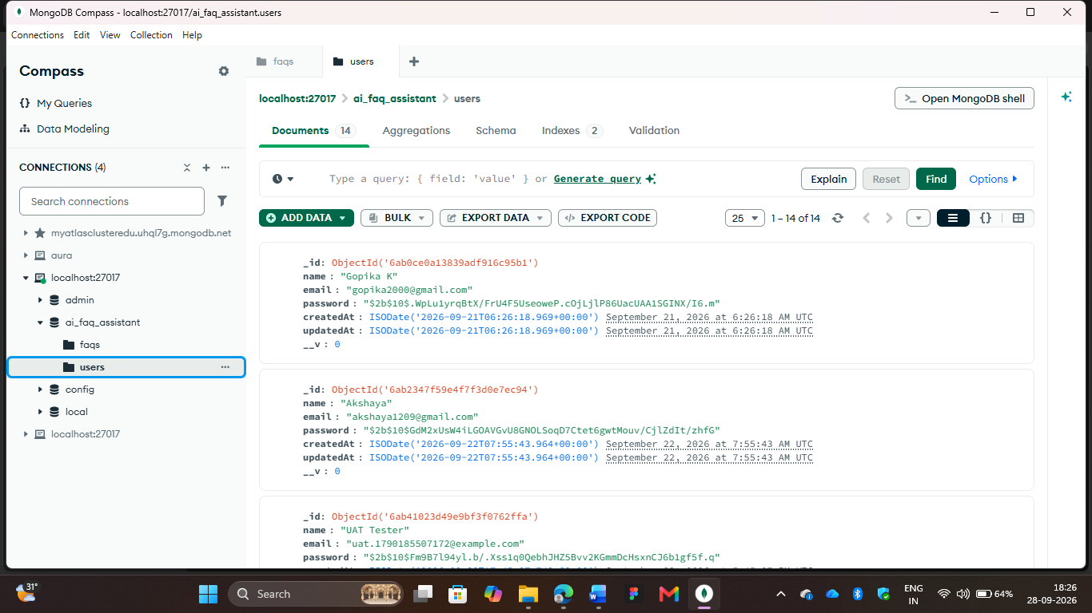

FAQs Collection

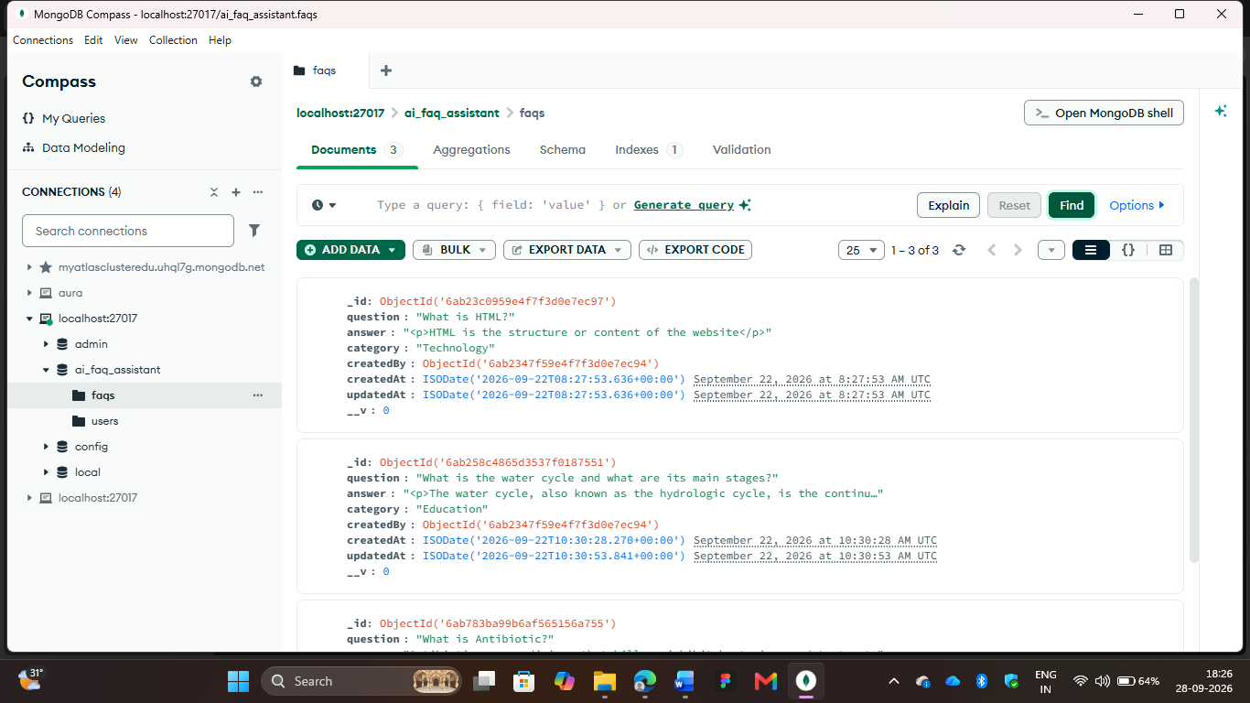

API Testing

Register
Register (POST /api/auth/register): Validates user input, hashes the password, creates a new user record in MongoDB, and returns a 201 Created status along with a JWT for session management.
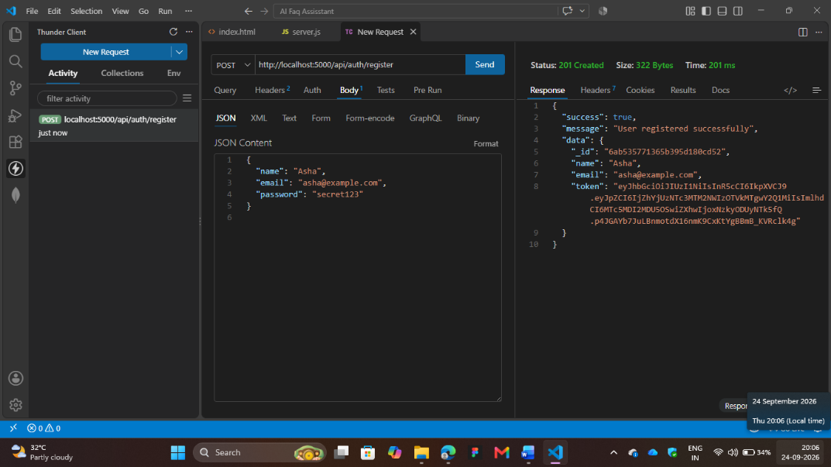

Login
Login (POST /api/auth/login): Authenticates credentials against the database and issues a secure JWT Bearer token upon success (200 OK).

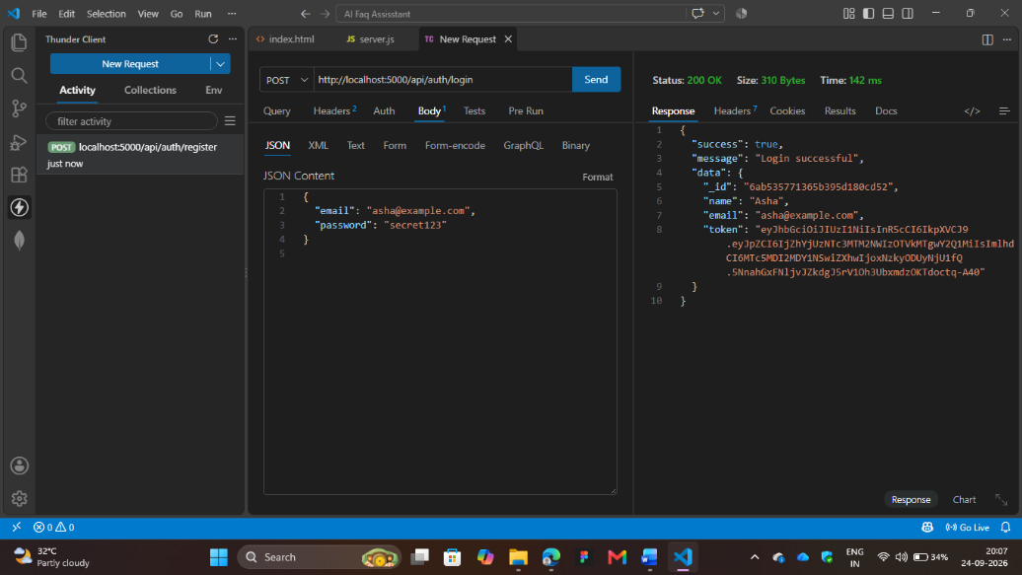

Profile
Profile (GET /api/auth/profile): Retrieves the authenticated user's details using the provided JWT, ensuring secure access to private data.

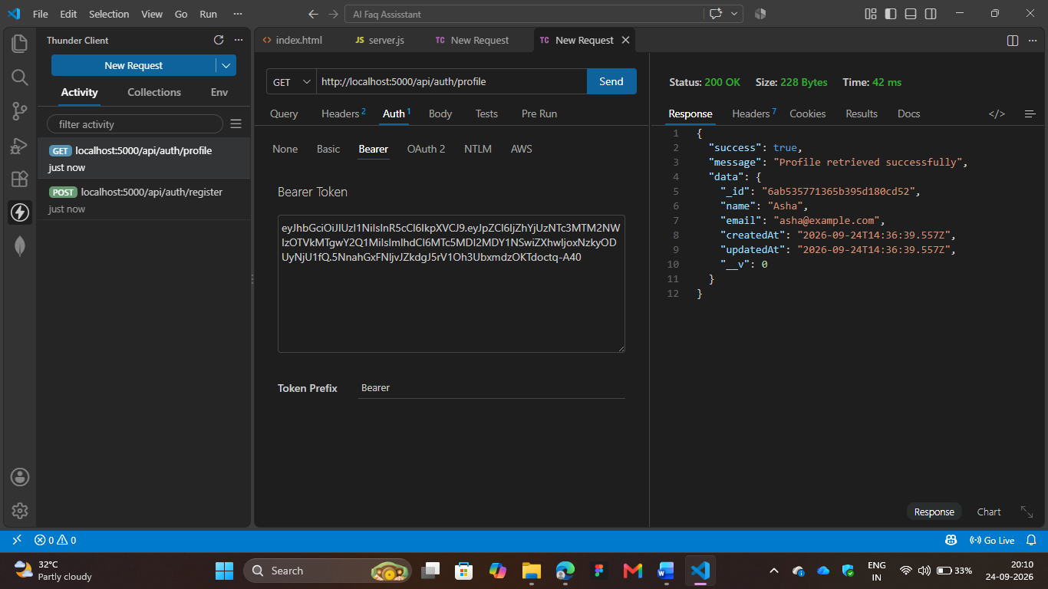

Create FAQ
Create FAQ (POST /api/faqs): A protected endpoint that accepts a question, answer, and category, saving the new FAQ to MongoDB linked to the authenticated creator's ID.

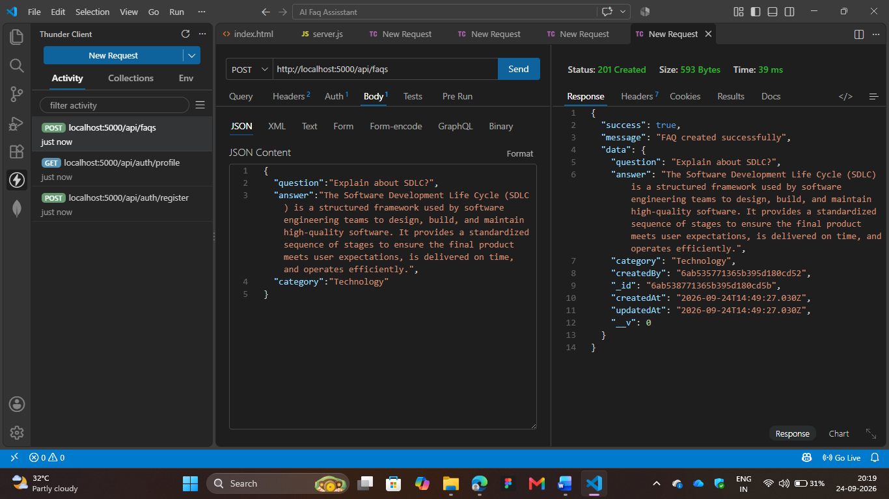

Get All FAQ
Get All FAQ (GET /api/faqs): Fetches and displays a JSON array of all publicly available FAQs from the database.

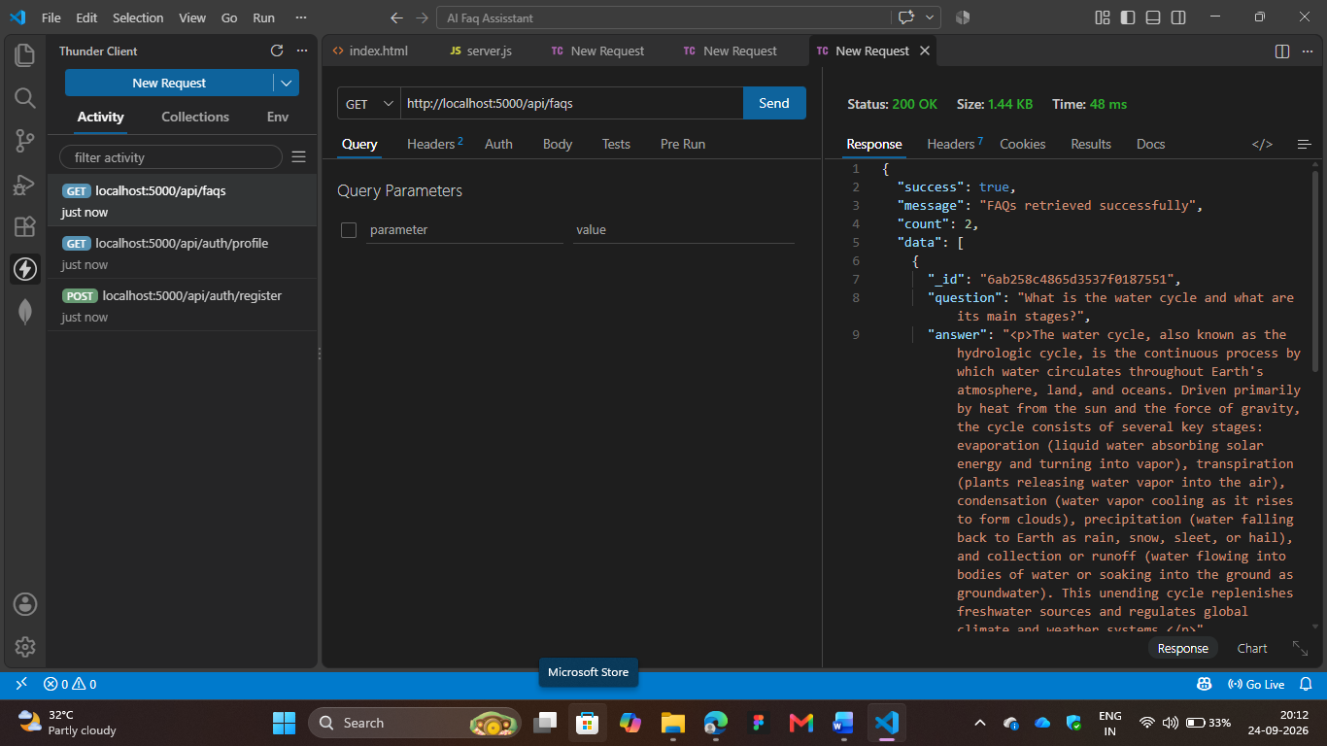

Get FAQ by ID
Get FAQ by ID (GET /api/faqs/:id): Retrieves a single, specific FAQ document based on its unique MongoDB ObjectId.

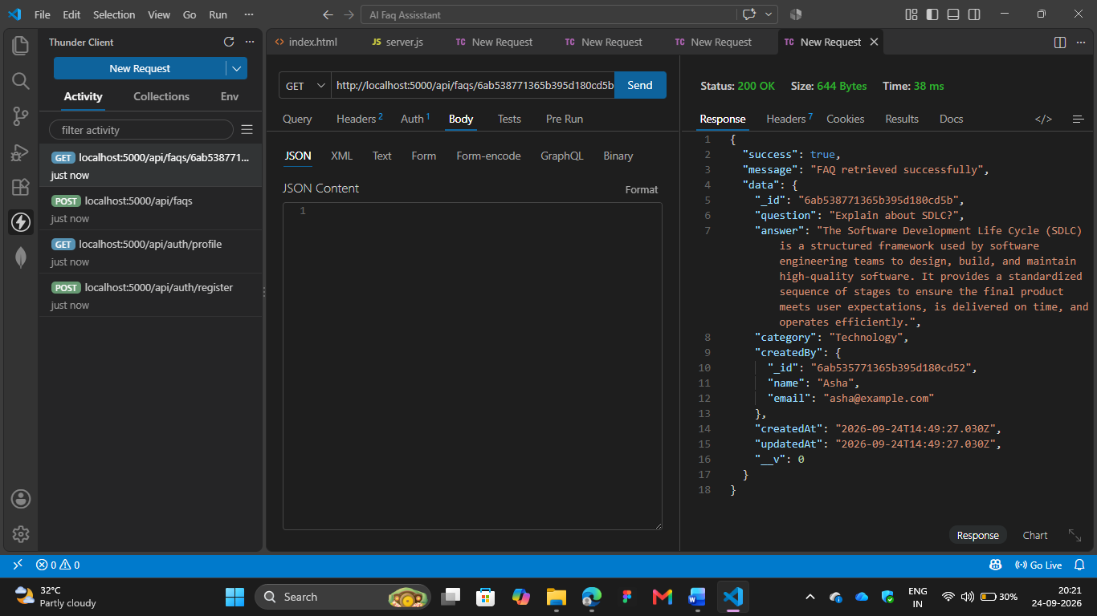

FAQ Update
FAQ Update (PUT /api/faqs/:id): Modifies an existing FAQ entry. The backend enforces ownership authorization so only the original creator can successfully execute this request.

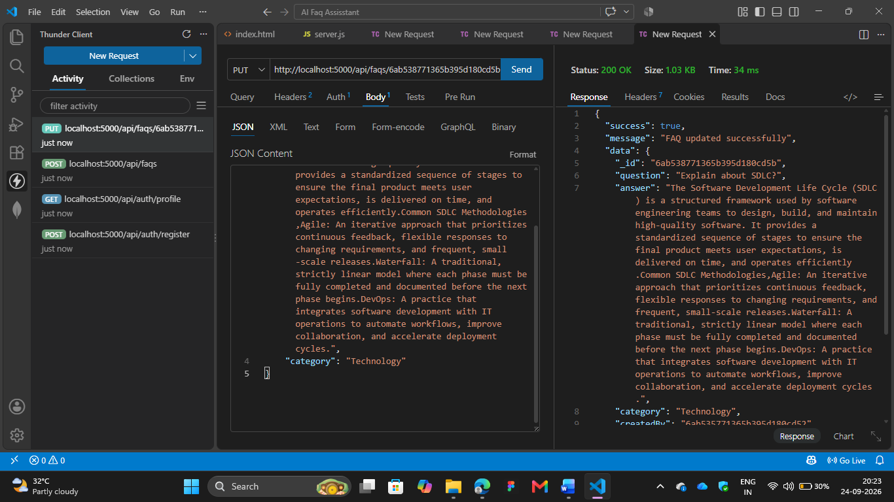

Delete FAQ
Delete FAQ (DELETE /api/faqs/:id): Removes a specific FAQ from the database, strictly protected by JWT verification and ownership validation

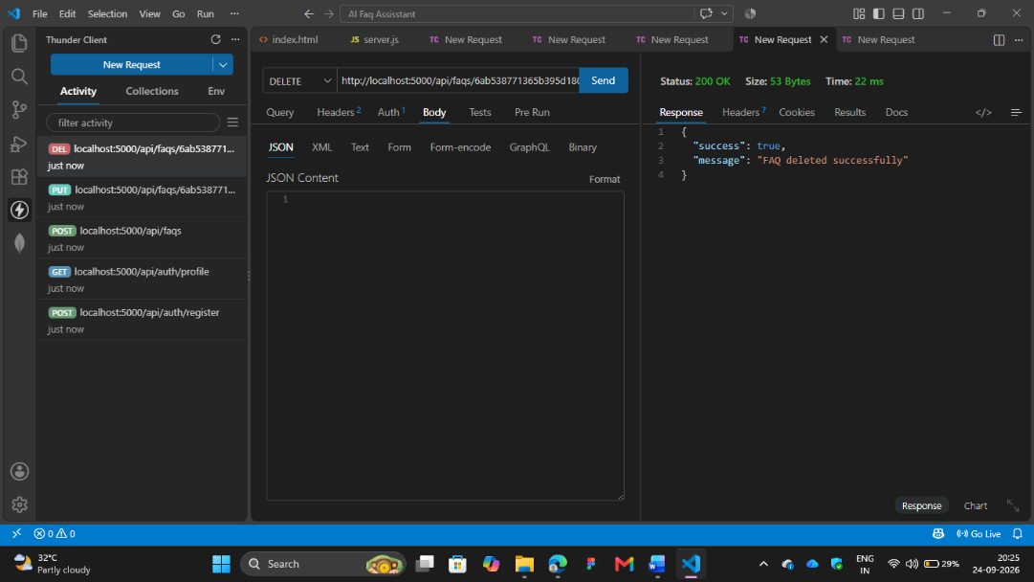

Search FAQ
Search FAQ (GET /api/faqs/search?q=...): Uses MongoDB regex matching to perform a case-insensitive keyword search across FAQ content, returning all relevant matches.

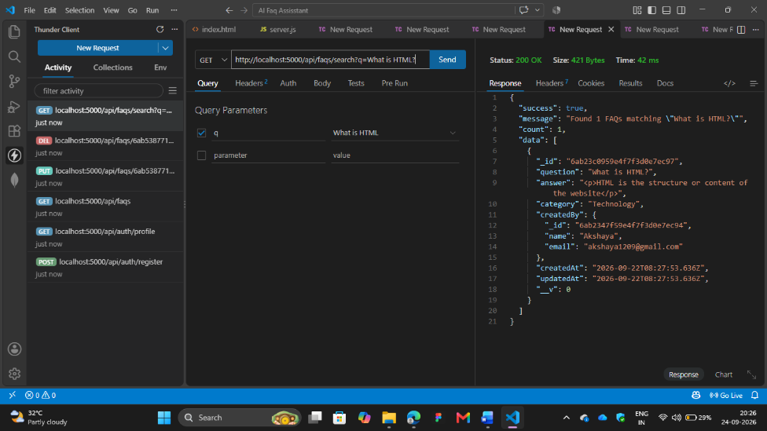

AI Answer Generation with Question
AI Answer Generation with Question (POST /api/ai/answer): Sends an arbitrary user question to the Gemini API and returns a concise, AI-generated text response directly to the client.
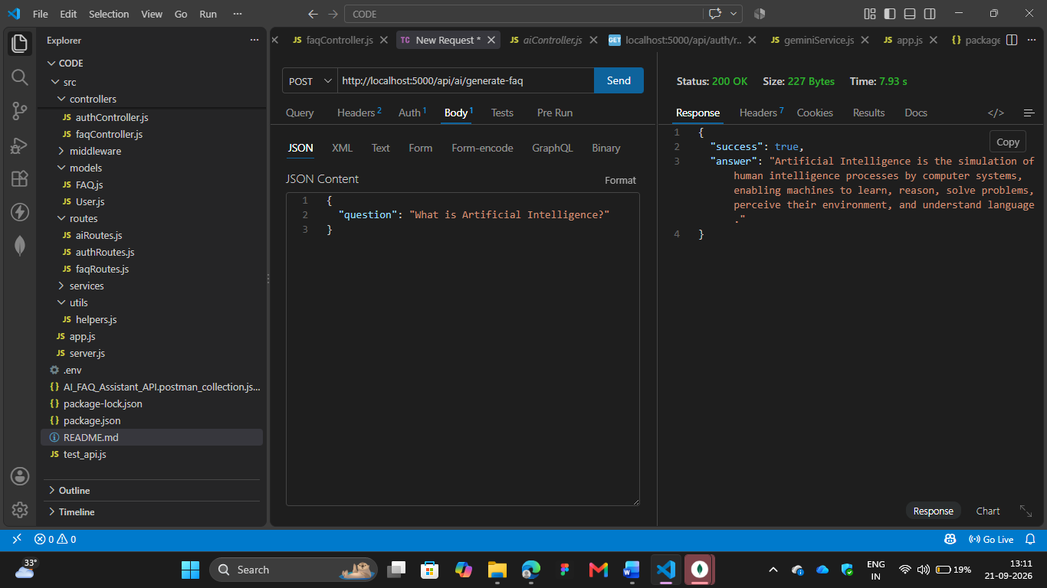

Generating Answer with Topic
Generating Answer with Topic (POST /api/ai/generate-faq): Submits a topic to the Gemini model using Structured JSON output, returning a perfectly formatted question-and-answer draft that can be subsequently saved as an FAQ.

